**Ministerul Educaţiei și Cercetării al Republicii Moldova**

**Universitatea Tehnică a Moldovei**

**Facultatea Calculatoare, Informatică și Microelectronică**

**RAPORT**

Lucrarea de laborator nr.7

*la Baza de date*

**Au efectuat: Vlasitchi Stefan**

**st. gr. TI-216**

**A verificat:**

**asist. univ. Cebotar Gabriela**

**Chişinău - 2023**

**Lucrare de laborator nr. 7**

**Tema:** Interogări unirelatie simple in SQL

**Sarcini practice:**

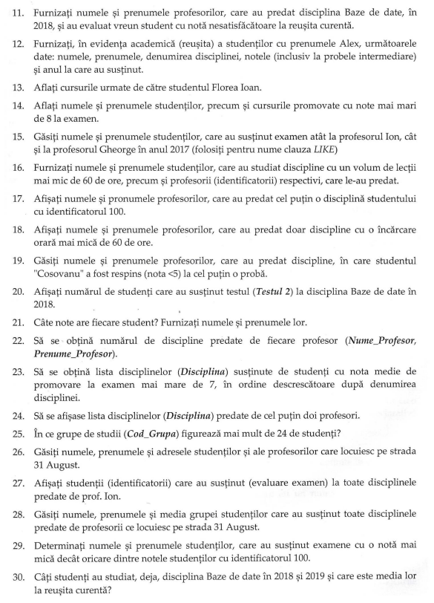

## Efectuarea sarcinilor

**Sarcina 6**

Afisati numele si prenumele primelor 5 studentii care au obtinut note in ordine descrescatoare

la al doilea test la disciplina Baze de Date sa se foloseasca optiunea TOP...WITH TIES

select TOP 5 with ties S.Nume_Student, S.Prenume_Student, SR.Nota, SR.Tip_Evaluare, D.Disciplina

from studenti S

join studenti_reusita SR

on SR.Id_Student=S.Id_Student

join discipline D

on D.Id_Disciplina=SR.Id_Disciplina

where SR.Tip_Evaluare='Testul 2' and D.Disciplina='Baze de Date' order by SR.Nota desc

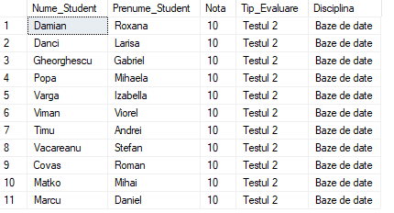

Figura 1. Rezultul interogarii

**Sarcina 7**

In ce grupa (Cod Grupa) invata studenti care locuiesc pe strada 31 August.

SELECT DISTINCT [gr].[Cod_Grupa], [stu].[Nume_Student], [stu].[Prenume_Student], [stu]. [Adresa_Postala_Student]

FROM [dbo].[grupe] AS [gr]

INNER JOIN [dbo].[studenti_reusita] AS [sr] ON [sr].[Id_Grupa] = [gr].[Id_Grupa]

INNER JOIN [dbo].[studenti] AS [stu] ON [stu].Id_Student = [sr].[Id_Student]

WHERE [stu].[Adresa_Postala_Student] LIKE '%31 August%'

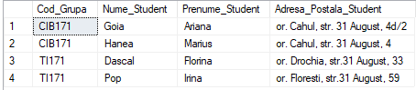

Figura 2. Rezultul interogarii

**Sarcina 8**

Obtineti identificatori si numele studentilor, ale examenelor sustinute in anul 2018.

SELECT DISTINCT [stu].Id_Student, [stu].[Nume_Student], [stu].[Prenume_Student], [sr].

[Data_Evaluare]

FROM [dbo].[studenti] AS [stu]

INNER JOIN [dbo].[studenti_reusita] AS [sr] ON [sr].Id_Student = [stu].[Id_Student] WHERE [sr].[Data_Evaluare] LIKE '2018%'

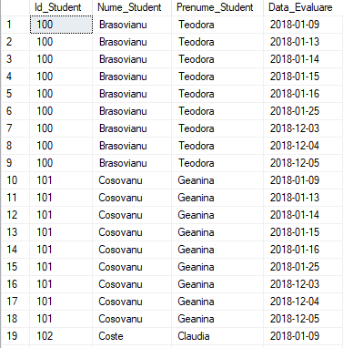

**Sarcina 9**

Gasiti numele, adresa studentilor si codul disciplinei la care studentii au avut cel putin

o nota in anul 2018.

SELECT DISTINCT[stu].[Nume_Student], [stu].[Prenume_Student],[stu].[Adresa_Postala_Student], [sr].[Nota], [dis].[Id_Disciplina],[dis].[Disciplina]

FROM [dbo].[studenti] AS [stu]

INNER JOIN [dbo].[studenti_reusita] AS [sr] ON [sr].[Id_Student] = [stu].[Id_Student] INNER JOIN [dbo].[discipline] AS [dis]

ON [dis].Id_Disciplina = [sr].[Id_Disciplina] WHERE [sr].[Nota] IS NOT NULL

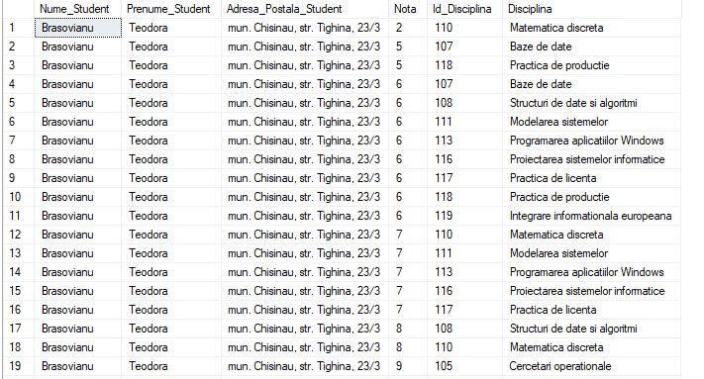

**Sarcina 10**

Gasiti studentii (numele, prenumele), care au obtinut la disciplina Baze de Date (examen),

in anul 2018, vrio nota mai mica ca 8 si mai mare ca 4.

SELECT [stu].[Nume_Student], [stu].[Prenume_Student] ,[dis].[Disciplina],[sr].[Nota], [sr]. [Tip_Evaluare]

FROM [dbo].[studenti] AS [stu]

INNER JOIN [dbo].[studenti_reusita] AS [sr] ON [sr].[Id_Student] = [stu].[Id_Student] INNER JOIN [dbo].[discipline] AS [dis]

ON [dis].Id_Disciplina = [sr].[Id_Disciplina]

WHERE [dis].[Disciplina] = 'Baze de date' AND [sr].[Tip_Evaluare] = 'Examen' AND [sr].[Nota]

BETWEEN 4 AND 8

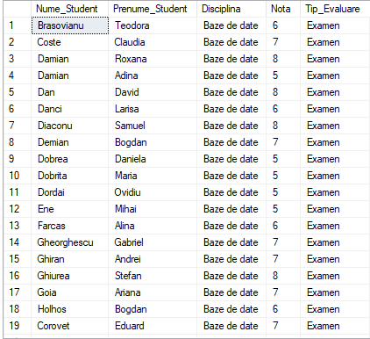

**Sarcina 11**

Furnizati numele si prenumele profesorilor, care au predat disciplina Baze de Date, in 2018,

si au evaluat vriun student cu nota nesatisfacatoare la reusita curenta

SELECT DISTINCT [pro].[Id_Profesor], [pro].Nume_Profesor, [pro].[Prenume_Profesor] FROM [dbo].[profesori] AS [pro]

INNER JOIN [dbo].studenti_reusita AS [sr] ON [sr].Id_Profesor = [pro].Id_Profesor INNER JOIN [dbo].[discipline] AS [dis]

ON [dis].[Id_Disciplina] = [sr].[Id_Disciplina]

WHERE [sr].[Data_Evaluare] LIKE '2018%' AND [dis].[Disciplina] = 'Baze de date' AND [sr].[Nota]

<= '4'



**Sarcina 12**

Furnizati, in evidenta (reusita) a studentilor cu prenumele Alex, urmatorele date: numele, prenumele, denumirea disciplinei notele (inclusiv la probele intermediare) si anul care au sustinut.

SELECT [stu].[Nume_Student], [stu].[Prenume_Student], [dis].[Disciplina], [sr].[Nota],[sr]. [Tip_Evaluare], [sr].[Data_Evaluare]

FROM [dbo].[studenti] AS [stu]

INNER JOIN [dbo].[studenti_reusita] AS [sr] ON [sr].[Id_Student] = [stu].[Id_Student] INNER JOIN [dbo].[discipline] AS [dis]

ON [dis].[Id_Disciplina] = [sr].[Id_Disciplina] WHERE [stu].[Prenume_Student] = 'Alex'

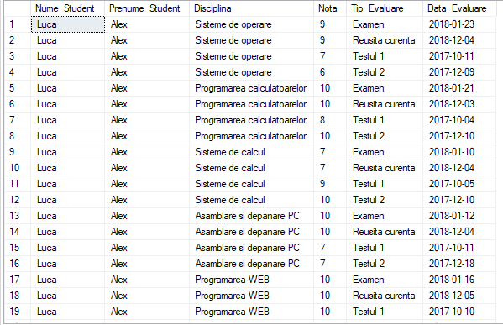

**Sarcina 13**

Aflati cursurile urmate de catre studentul Florea Ioan

SELECT DISTINCT [stu].[Nume_Student], [stu].[Prenume_Student], [dis].[Disciplina] FROM [dbo].[studenti] AS [stu]

INNER JOIN [dbo].[studenti_reusita] AS [sr] ON [sr].[Id_Student] = [stu].[Id_Student] INNER JOIN [dbo].[discipline] AS [dis]

ON [dis].[Id_Disciplina] = [sr].[Id_Disciplina]

WHERE [stu].[Nume_Student] = 'Florea' AND [stu].[Prenume_Student] = 'Ioan'

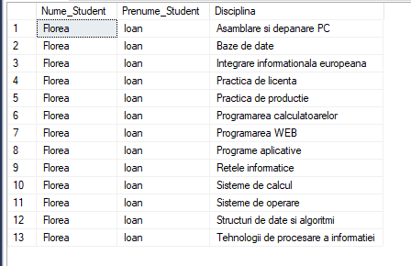

**Sarcina 14**

Aflanti numele si prenumele studentilor, precum si cursurile promovate cu note mai mari de

SELECT [stu].[Nume_Student], [stu].[Prenume_Student], [dis].[Disciplina], [sr]. [Tip_Evaluare], [sr].[Nota]

FROM [dbo].[studenti] AS [stu]

INNER JOIN [dbo].[studenti_reusita] AS [sr] ON [sr].[Id_Student] = [stu].[Id_Student] INNER JOIN [dbo].[discipline] AS [dis]

ON [dis].[Id_Disciplina] = [sr].[Id_Disciplina]

WHERE [sr].[Tip_Evaluare] = 'Examen' AND [sr].[Nota] >= 8

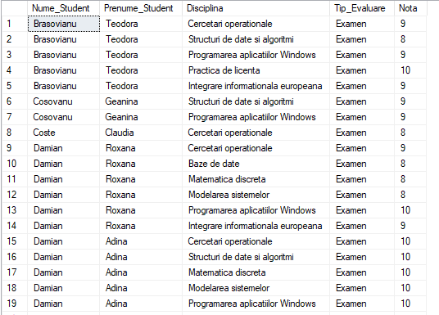

**Sarcina 15**

Aflati numele si prenumele studentilor, care au sustinut examenat atat la profesorul Ion,

cit si la profesorul Gheorghe in anul 2017 (folosit pentru nume clauza LIKE)

SELECT [stu].[Nume_Student], [stu].[Prenume_Student],[sr].[Tip_Evaluare],[pro]. [Nume_Profesor],[pro].[Prenume_Profesor]

FROM [dbo].[studenti] AS [stu]

INNER JOIN [dbo].[studenti_reusita] AS [sr] ON [sr].[Id_Student] = [stu].[Id_Student] INNER JOIN [dbo].[profesori] AS [pro]

ON [pro].[Id_Profesor] = [sr].[Id_Profesor]

WHERE [sr].[Data_Evaluare] LIKE '2017%' AND [sr].[Tip_Evaluare] Like 'Testul 2' AND [pro]. [Prenume_Profesor] LIKE 'Ion' --AND [pro].[Prenume_Profesor] LIKE '%Ion%'

UNION

SELECT [stu].[Nume_Student], [stu].[Prenume_Student],[sr].[Tip_Evaluare],[pro]. [Nume_Profesor],[pro].[Prenume_Profesor]

FROM [dbo].[studenti] AS [stu]

INNER JOIN [dbo].[studenti_reusita] AS [sr] ON [sr].[Id_Student] = [stu].[Id_Student] INNER JOIN [dbo].[profesori] AS [pro]

ON [pro].[Id_Profesor] = [sr].[Id_Profesor]

WHERE [sr].[Data_Evaluare] LIKE '2017%' AND [sr].[Tip_Evaluare] Like 'Testul 2' AND [pro]. [Prenume_Profesor] LIKE 'Georghe'

--[sr].[Data_Evaluare] LIKE '2017%' AND

select * FROM profesori --!!! IN anul 2017 profesori ion nu au avut examene iar profesor cu prenumele george nu a predate

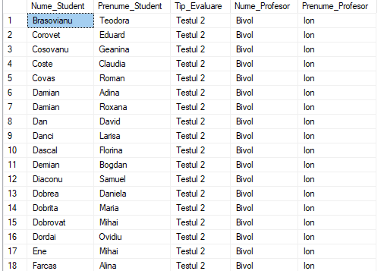

**Sarcina 16**

Furnizati numele si prenumele studentilor, care au studiat discipline cu un volum de lectii

mai mic de 60 de ore, precum si profesori (identificatorii) respectivi, care le-au predat.

SELECT DISTINCT [stu].[Nume_Student], [stu].[Prenume_Student], [dis].[Disciplina], [dis]. [Nr_ore_plan_disciplina],[pro].[Id_Profesor],[pro].[Nume_Profesor],[pro].[Prenume_Profesor]

FROM [dbo].[studenti] AS [stu]

INNER JOIN [dbo].[studenti_reusita] AS [sr] ON [sr].[Id_Student] = [stu].[Id_Student] INNER JOIN [dbo].[discipline] AS [dis]

ON [dis].[Id_Disciplina] = [sr].[Id_Disciplina] INNER JOIN [dbo].[profesori] AS [pro]

ON [pro].[Id_Profesor] = [sr].[Id_Profesor] WHERE [dis].[Nr_ore_plan_disciplina] <= '60'

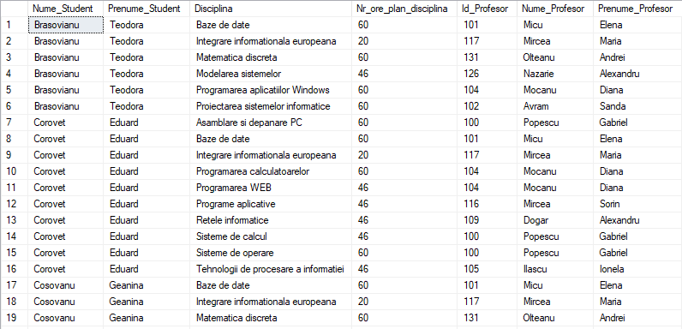

**Sarcina 17**

Afisati numele si prenumele profesorilor, care au predat cel putin o disciplina studentului cu identificatorul 100.

SELECT DISTINCT [pro].[Nume_Profesor],[pro].[Prenume_Profesor], [dis].Disciplina, [stu]. [Id_Student], [stu].[Nume_Student],[stu].[Prenume_Student]

FROM [dbo].[studenti] AS [stu]

INNER JOIN [dbo].[studenti_reusita] AS [sr] ON [sr].[Id_Student] = [stu].[Id_Student] INNER JOIN [dbo].[discipline] AS [dis]

ON [dis].[Id_Disciplina] = [sr].[Id_Disciplina] INNER JOIN [dbo].[profesori] AS [pro]

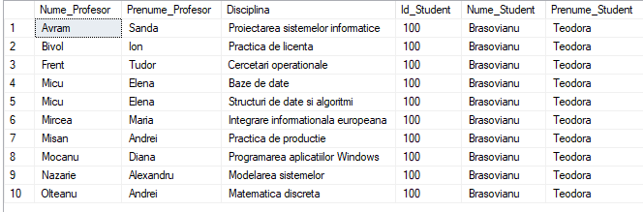ON [pro].[Id_Profesor] = [sr].[Id_Profesor] WHERE [stu].[Id_Student] = '100'

**Sarcina 18**

Afisati numele si prenumele profesorilor, care au predat doar discipline cu o incarcare orara mai mica de 60 de ore.

SELECT DISTINCT [pro].[Nume_Profesor], [pro].[Prenume_Profesor], [dis].[Disciplina], [dis]. [Nr_ore_plan_disciplina]

FROM [dbo].[profesori] AS [pro]

INNER JOIN [dbo].studenti_reusita AS [sr] ON [sr].Id_Profesor = [pro].Id_Profesor INNER JOIN [dbo].[discipline] AS [dis]

ON [dis].[Id_Disciplina] = [sr].[Id_Disciplina] WHERE [dis].[Nr_ore_plan_disciplina] <= '60'

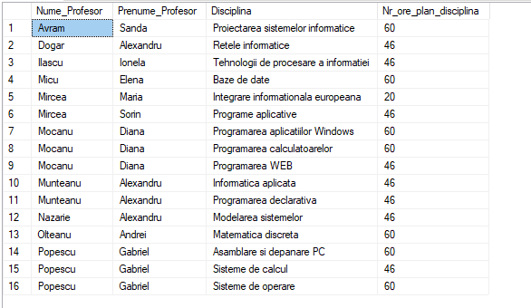

**Sarcina 19**

Gasiti numele si prenumele profesorilor, care au predat disciplina, in care studentul "Cosovanu" a fost respins (nota < 5) la cel putin o proba.

SELECT [pro].[Nume_Profesor], [pro].[Prenume_Profesor], [dis].[Disciplina], [sr].[Tip_Evaluare], [sr].[Nota], [stu].[Nume_Student], [stu].[Prenume_Student]

FROM [dbo].[profesori] AS [pro]

INNER JOIN [dbo].[studenti_reusita] AS [sr] ON [sr].[Id_Profesor] = [pro].[Id_Profesor] INNER JOIN [dbo].[discipline] AS [dis]

ON [dis].[Id_Disciplina] = [sr].[Id_Disciplina] INNER JOIN [dbo].[studenti] AS [stu]

ON [stu].[Id_Student] = [sr].[Id_Student]

WHERE [stu].[Nume_Student] = 'Cosovanu' AND [sr].[Nota] < = '4'

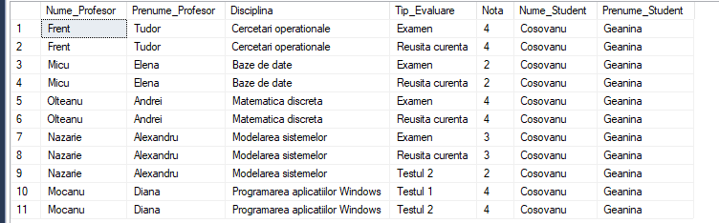

**Sarcina 20**

Afisati numarul de studenti care au sustinut testul (Testul 2) la disciplina Baze de Date in 2018.

SELECT COUNT([stu].[Id_Student]) --Nume_Student,Prenume_Student,Disciplina,Tip_Evaluare

--COUNT([stu].[Id_Student])

FROM [dbo].[studenti] AS [stu]

INNER JOIN [dbo].[studenti_reusita] AS [sr] ON [sr].[Id_Student] = [stu].[Id_Student] INNER JOIN [dbo].[discipline] AS [dis]

ON [dis].[Id_Disciplina] = [sr].[Id_Disciplina] WHERE [sr].[Tip_Evaluare] = 'Testul 2'



**Sarcina 21**

Cite note are fiecar student? Furnizati numele si prenumele lor.

SELECT [stu].[Nume_Student], [stu].[Prenume_Student], NrNote = (SELECT COUNT ([sr].[Nota])

FROM [dbo].[studenti_reusita] AS [sr] WHERE [sr].[Id_Student] = [stu].[Id_Student])

FROM [dbo].[studenti] AS [stu]

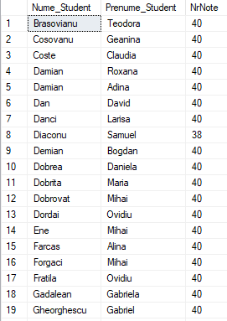

**Sarcina 22**

Sa se obtina numarul de discipline predate de fiecare profesor (Nume_Profesor, Prenume_profesor).

SELECT [pro].[Id_Profesor], [pro].[Nume_Profesor], [pro].[Prenume_Profesor], [NrDisciplinePredate] = (

SELECT DISTINCT COUNT([dis].[Id_Disciplina] ) FROM [dbo].[discipline] AS [dis]

WHERE [dis].[Id_Disciplina] IN ( SELECT [sr].[Id_Disciplina]

FROM [dbo].[studenti_reusita] AS [sr]

WHERE [sr].[Id_Profesor] = [pro].[Id_Profesor] )) FROM [dbo].[profesori] AS [pro]

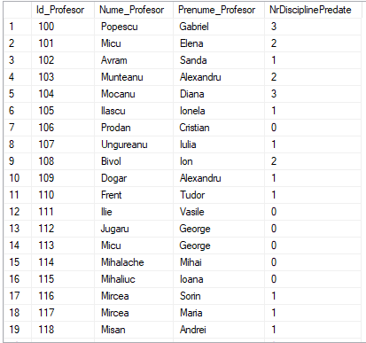

**Sarcina 23**

Sa se obtina lista disciplinelor (Disciplina) sustinute de studentii cu nota medie de

promovare la examen mai mare de 7, in ordine descrescatoare dupa denumirea disciplineis.

SELECT [dis].[Disciplina], [sr].[Tip_Evaluare], [sr].[Nota], [stu].[Nume_Student], [stu].

[Prenume_Student]

FROM [dbo].[discipline] AS [dis]

INNER JOIN [dbo].[studenti_reusita] AS [sr] ON [sr].[Id_Disciplina] = [dis].[Id_Disciplina] INNER JOIN [dbo].[studenti] AS [stu]

ON [stu].Id_Student = [sr].[Id_Student]

WHERE [sr].[Tip_Evaluare] = 'Examen' AND [sr].[Nota] > 7

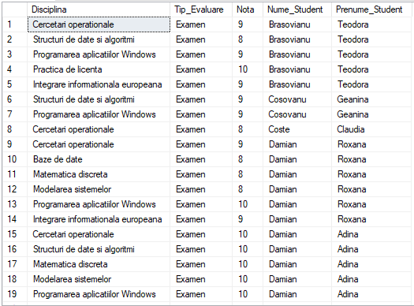

**Sarcina 24**

Sa se afiseze lista disciplinelor(Disciplina)predta de cel putin doi profesori.

SELECT [Disciplina], COUNT([Id_Profesor]) AS NrProfesori FROM (SELECT DISTINCT [dis].[Disciplina], [sr].[Id_Profesor]

FROM [dbo].[studenti_reusita] AS [sr] JOIN [dbo].[discipline] AS [dis] ON [sr].Id_Disciplina = [dis].[Id_Disciplina]

) AS TEMPTable GROUP BY [Disciplina]

HAVING COUNT(Id_Profesor) >1

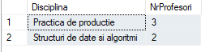

**Sarcina 25**

In ce grupe de studii (Cod_Grupa) figureaza mai mult de 24 de studenti

SELECT DISTINCT [Cod_Grupa], COUNT([Id_Student]) AS [NrStudenti] FROM (SELECT DISTINCT [gru].[Cod_Grupa],[sr].[Id_Student]

FROM [dbo].[grupe] AS [gru]

JOIN [dbo].[studenti_reusita] AS [sr] ON [sr].[Id_Grupa] = [gru].[Id_Grupa]

--JOIN [dbo].[studenti] AS [stu] ON [stu].[Id_Student] = [sr].[Id_Student]

) AS TEMPTable GROUP BY [Cod_Grupa]

HAVING COUNT(Id_Student) > 24

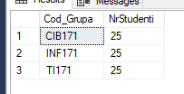

**Sarcina 26**

Gasiti numele, prenumele si adresele studentilor si ale profesorilor care locuiesc pe

-- strada 31 August

SELECT [stu].[Nume_Student],[stu].[Prenume_Student], [ocupatia] = 'student' FROM [dbo].[studenti] AS [stu]

WHERE [stu].[Adresa_Postala_Student] LIKE '%Chisinau%' --LIKE '%31 August%' UNION

SELECT [pro].[Nume_Profesor],[pro].[Prenume_Profesor], [ocupatia] = 'profesor' FROM [dbo].[profesori] AS [pro]

WHERE [pro].[Adresa_Postala_Profesor] LIKE '%Chisinau%' --LIKE '%31 August%'

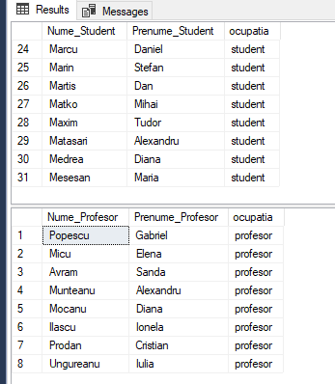

**Sarcina 27**

Aflati studentii (identificatorii) care au sustinut (evaluarea examen) la toate disciplinele de profesorul Ion

SELECT [stu].[Id_Student], [stu].Nume_Student, [stu].[Prenume_Student], [sr].[Nota], [sr]. [Tip_Evaluare], [dis].[Disciplina], [pro].[Id_Profesor], [pro].[Nume_Profesor], [pro].[Prenume_Profesor]

FROM [dbo].[studenti] AS [stu]

INNER JOIN [dbo].[studenti_reusita] AS [sr] ON [sr].[Id_Student] = [stu].[Id_Student] INNER JOIN [dbo].[profesori] AS [pro]

ON [pro].[Id_Profesor] = [sr].[Id_Profesor] INNER JOIN [dbo].[discipline] AS [dis]

ON [dis].[Id_Disciplina] = [sr].[Id_Disciplina]

WHERE [pro].[Prenume_Profesor] = 'Ion' AND [sr].[Tip_Evaluare] = 'Examen'

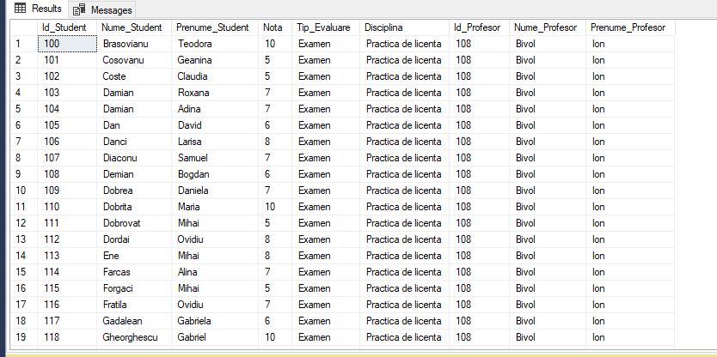

**Sarcina 28**

Gasiti numele prenumele si media grupei studentilor care au sustinut toate disciplinele predate de profesori care locuiesc pe strada 31 August.

SELECT DISTINCT [stu].[Nume_Student],[stu].[Prenume_Student], [Media] = ( SELECT AVG([sr].[Nota])

FROM [dbo].[studenti_reusita] AS [sr] WHERE [sr].[Id_Student] = [stu].[Id_Student]

) ,[dis].[Id_Disciplina], [dis].[Disciplina], [pro].[Id_Profesor], [pro].[Nume_Profesor], [pro].[Prenume_Profesor], [pro].[Adresa_Postala_Profesor]

FROM [dbo].[studenti] AS [stu]

INNER JOIN [dbo].[studenti_reusita] AS [sr] ON [sr].[Id_Student] = [stu].[Id_Student] INNER JOIN [dbo].[profesori] AS [pro] ON [pro].[Id_Profesor] = [sr].[Id_Profesor] INNER JOIN [dbo].[discipline] AS [dis] ON [dis].[Id_Disciplina] = [sr].[Id_Disciplina] WHERE [pro].[Adresa_Postala_Profesor] LIKE '%bd. Dacia%'

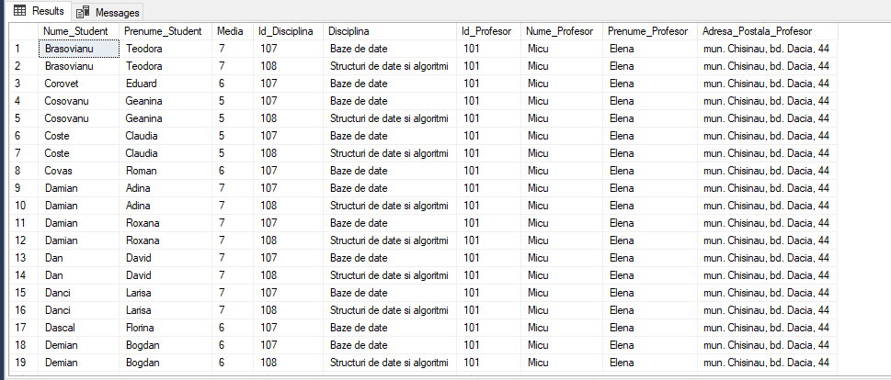

**Sarcina 29**

Determinati numele si prenumele studentilor, care au sustinut examene cu o nota mai mica decit oricare dintre notele studentilor cu identificatorul 100.

SELECT [stu].[Nume_Student], [stu].[Prenume_Student], [sr].[Nota], [sr].[Tip_Evaluare], [dis]. [Disciplina] --[sr].[Nota])

FROM [dbo].[studenti] AS [stu]

INNER JOIN [dbo].[studenti_reusita] AS [sr] ON [sr].Id_Student = [stu].[Id_Student] INNER JOIN [dbo].[discipline] AS [dis] ON [dis].[Id_Disciplina] = [sr].[Id_Disciplina] WHERE [sr].[Tip_Evaluare] = 'Examen' AND [sr].[Nota] < = (

SELECT MIN([sr].[Nota])

FROM [dbo].[studenti_reusita] AS [sr]

WHERE [sr].[Id_Student] = 100 --AND [sr].[Tip_Evaluare] = 'Examen'

)

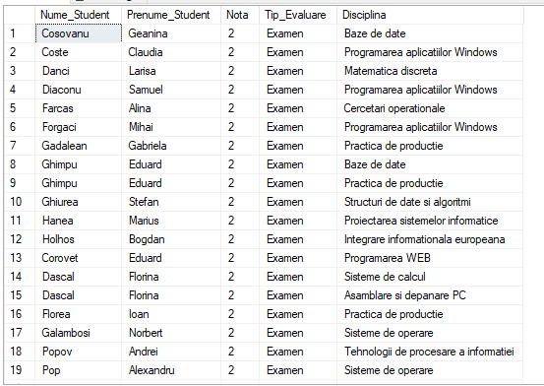

**Sarcina 30**

Cati studenti au studiat, deja disciplina Baze de Date in 2018 si 2019 si care este media lor la reusita curenta?

SELECT [dis].[Disciplina], COUNT(DISTINCT [stu].[Id_Student]) AS [NrStudenti], AVG([sr].[Nota]) AS [MedieReusitaCurenta]

FROM [dbo].[studenti_reusita] AS [sr]

INNER JOIN [dbo].[discipline] AS [dis] ON [dis].[Id_Disciplina] = [sr].[Id_Disciplina]

INNER JOIN [dbo].[studenti] AS [stu] ON [stu].[Id_Student] = [sr].[Id_Student]

WHERE [dis].[Disciplina] = 'Baze de Date' AND ((YEAR([sr].[Data_Evaluare]) = 2018 AND [sr].[Data_Evaluare] >= '2018-01-01' AND [sr].[Data_Evaluare] <= '2018-12-31') OR

(YEAR([sr].[Data_Evaluare]) = 2019) )

GROUP BY [dis].[Disciplina];



**Sarcina 31**

Furnizati numele si prenumele studentilor, care au avut mai mult de doua dezaprobari intr-unan la o disciplina.

SELECT [stu].[Nume_Student], [stu].[Prenume_Student], COUNT([sr].[Id_Student]) AS Numar_Restante

FROM [dbo].[studenti] AS [stu]

INNER JOIN [dbo].[studenti_reusita] AS [sr] ON [sr].[Id_Student] = [stu].[Id_Student]

INNER JOIN [dbo].[discipline] AS [dis] ON [dis].[Id_Disciplina] = [sr].[Id_Disciplina]

WHERE [sr].[Nota] < 4 AND [sr].[Data_Evaluare] LIKE '2018%'

GROUP BY [stu].[Id_Student], [stu].[Nume_Student], [stu].[Prenume_Student]

HAVING COUNT([sr].[Id_Student]) > 2;

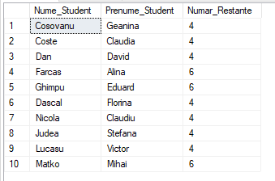

**Sarcina 32**

Furnizati numele, prenumel si media notelor pe grupe pentru studenti.

SELECT DISTINCT [gru].[Cod_Grupa], [stu].[Nume_Student], [stu].[Prenume_Student], [MediaNotelor] = (SELECT AVG([sr].[Nota]) FROM [dbo].[studenti_reusita] AS [sr]

WHERE [sr].[Id_Student] = [stu].[Id_Student] ) FROM [dbo].[studenti] AS [stu]

INNER JOIN [dbo].[studenti_reusita] AS [sr] ON [sr].[Id_Student] = [stu].[Id_Student] INNER JOIN [dbo].[grupe] AS [gru] ON [gru].[Id_Grupa] = [sr].[Id_Grupa]

ORDER BY [gru].[Cod_Grupa], [stu].[Nume_Student], [stu].[Prenume_Student]

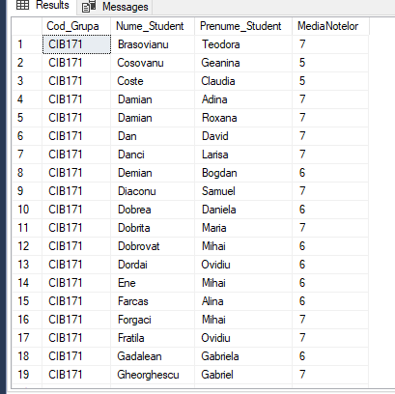

**Sarcina 33**

Gasiti numele si prenumele studentilor, care nu au luat nota de promovare la reusita curenta la nici o disciplina

SELECT [stu].[Id_Student], [stu].[Nume_Student], [stu].[Prenume_Student], [dis].[Disciplina], [sr].[Tip_Evaluare], [sr].[Nota]

FROM [dbo].[studenti] AS [stu]

INNER JOIN [dbo].[studenti_reusita] AS [sr] ON [sr].[Id_Student] = [stu].[Id_Student] INNER JOIN [dbo].[discipline] AS [dis] ON [dis].[Id_Disciplina] = [sr].[Id_Disciplina] WHERE [sr].[Tip_Evaluare] = 'Reusita curenta' AND [sr].[Nota] < = 4

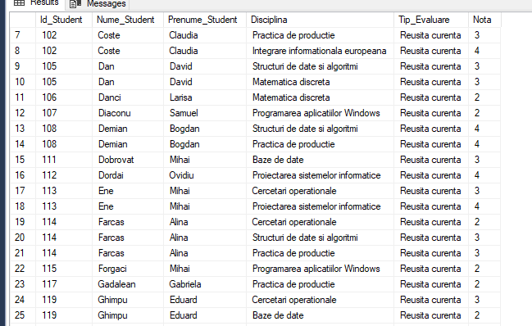

**Sarcina 34**

Gasiti numele si prenumele studentilor, care nu au luat note de promovare (inclusiv note intermediare) la nici o disciplina.

SELECT [stu].[Nume_Student], [stu].[Prenume_Student]

FROM [dbo].[studenti] AS [stu]

WHERE [stu].[Id_Student] NOT IN (

SELECT DISTINCT [sr].[Id_Student]

FROM [dbo].[studenti_reusita] AS [sr]

WHERE [sr].[Tip_Evaluare] = 'Note Intermediare' AND [sr].[Nota] > 5);

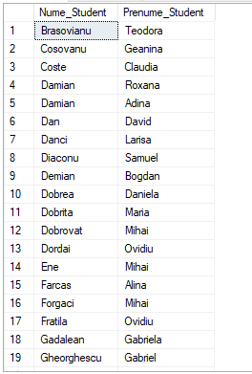

**Sarcina 35**

Gasiti denumirile disciplinelor si media notelor pe disciplina. Afisati numai disciplinel cu media mai mare de 7.0.

SELECT DISTINCT [dis].[Disciplina], AVG([sr].[Nota]) AS [nota] FROM [dbo].[discipline] AS [dis]

INNER JOIN [dbo].[studenti_reusita] AS [sr] ON [sr].[Id_Disciplina] = [dis].[Id_Disciplina] GROUP BY [dis].[Disciplina]

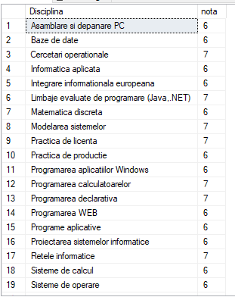

**Sarcina 37**

Gasiti disciplina sustinuta de studenti cu nota medie (la examen) ce mai inalta.

SELECT TOP 1 [dis].[Disciplina], [sr].[Tip_Evaluare], notaMedie = AVG([sr].[Nota])

FROM [dbo].[discipline] AS [dis]

INNER JOIN [dbo].[studenti_reusita] AS [sr] ON [sr].[Id_Disciplina] = [dis].[Id_Disciplina]

WHERE [sr].[Tip_Evaluare] = 'Examen'

GROUP BY [dis].[Disciplina], [sr].[Tip_Evaluare]

ORDER BY notaMedie DESC;



**Sarcina 38**

Furnizati denumirile disciplinelor cu o medie mai mica decit media notelor de la disciplina

SELECT [dis].[Disciplina], AVG([sr].[Nota]) AS 'NotaMedie' FROM [dbo].[discipline] AS [dis]

INNER JOIN [dbo].[studenti_reusita] AS [sr] ON [sr].[Id_Disciplina] = [dis].[Id_Disciplina] GROUP BY [dis].[Disciplina]

HAVING [dis].[Disciplina] != 'Baze de Date' AND AVG([sr].[Nota]) < = ( SELECT AVG([sr1].[Nota])

FROM [dbo].[studenti_reusita] AS [sr1]

INNER JOIN [dbo].[discipline] AS [dis1] ON [dis1].[Id_Disciplina] = [sr1].[Id_Disciplina] WHERE [dis1].[Disciplina] = 'Baze de Date')

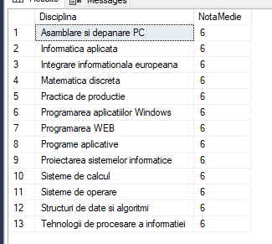

**Sarcina 39**

Gasiti denumirile disciplinelor la care nu au sustinut examenul, in medie, peste 5% de studenti.

SELECT [dis].[Disciplina]

FROM [dbo].[discipline] AS [dis]

LEFT JOIN [dbo].[studenti_reusita] AS [sr] ON [sr].[Id_Disciplina] = [dis].[Id_Disciplina]

GROUP BY [dis].[Disciplina]

HAVING AVG(CASE WHEN [sr].[Tip_Evaluare] = 'Examen' AND [sr].[Nota] >= 5 THEN 1 ELSE 0 END) <= 0.05 OR AVG(CASE WHEN [sr].[Tip_Evaluare] = 'Examen' THEN 1 ELSE 0 END) IS NULL;

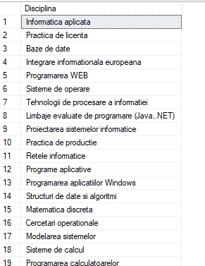

**Concluzie**

În această lucrare de laborator, s-a explorat utilizarea interogărilor unirelație simple în limbajul SQL. S-au implementat interogări eficiente pentru extragerea informațiilor necesare dintr-o singură tabelă, evidențiindu-se abilitățile de filtrare, grupare și calculare a datelor. A fost analizată importanța comenzilor `SELECT`, `FROM`, și `WHERE` în obținerea rezultatelor dorite. Această experiență consolidează înțelegerea practică a manipulării datelor într-un mediu de bază al bazelor de date relaționale.